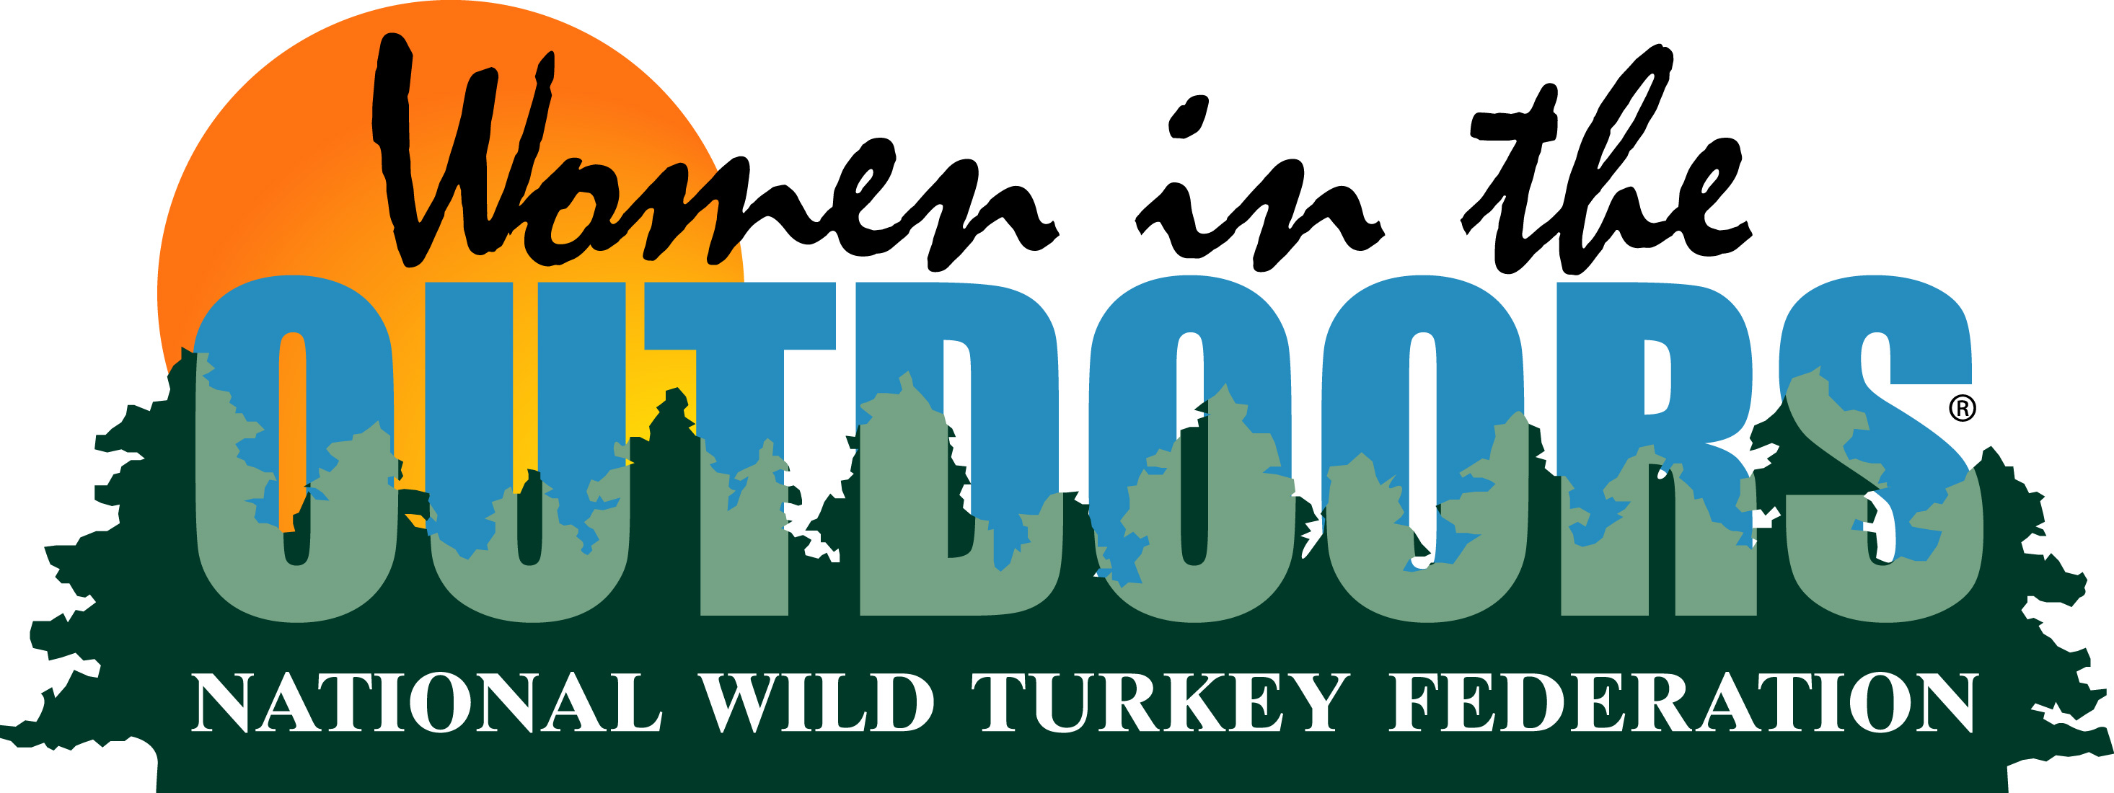

Do you enjoy activities in the out of doors? Would you like to learn outdoor skills or brush up on old ones, and network with other women who enjoy the same outdoor activities as you enjoy?

Then come and participate in a National Wild Turkey Federation’s Women in the Outdoors event! You will learn outdoor skills in a non-competitive environment. Skills that you can take home and share with family and friends. Make new friends and maybe take up a new hobby.

Come and join the fun!

2008 -- Pennsylvania Events

January 26
PA State Chapter and Cabela’s
Tammy Mowry (724) 284-9201, tammynwtf@zoominternet.net
Steven Pickett (610) 929-7040, steven.pickett@cabelas.com
Cabela’s, Hamburg (Berks County)

March 1

Moraine Chapter
Tammy Mowry (724) 284-9201, tammynwtf@zoominternet.net
Butler City Hunting & Fishing Club, East Butler (Butler County)

March 28 - 30
Pennsylvania State Chapter
Rhonda Henry (814) 443-6241, rhondapa@hotmail.com
Tammy Mowry (724) 284-9201, tammynwtf@zoominternet.net
Frank T. Soles YMCA Camp, Rockwood (Somerset County)

April 19
Allegheny Valley Chapter
Heather Wells (724) 265-4883, HeatherWells531@msn.com
Bullcreek Sportsmen’s Club, Tarentum (Allegheny County)

April 20
North Boros Double Beards Chapter
Cathy Schmid (412) 766-7687), schmidcathy@hotmail.com
Kimberly Lehnhardt (412) 867-1937
Sportsman’s Warehouse, Pittsburgh (Allegheny County)

May 2-4
PA State Chapter and Carlisle YMCA
Tammy Mowry (724) 284-9201, tammynwtf@zoominternet.net
Bonnie Berk 717-243-2525, ext. 222, bonnieberk@comcast.net
Camp Thompson YMCA Camp, Gardners, PA (Adams County)

May 16 & 17
PA State Chapter and Black Moshannon State Park
Michelle McCloskey (814) 342-5960, blackmoshannonsp@state.pa.us
Tammy Mowry (724) 284-9201, tammynwtf@zoominternet.net
Black Moshannon State Park, Philipsburg (Centre County)
May 31
Kinzua Allegheny Chapter
Jessica Arnold (814) 436-1048, duckdog@outdrs.net
Chapman State Park, Clarendon (Warren County)
May 31

Sherman’s Valley Strutters Chapter
Judy Bitting (717) 834-5908, judybitting@hotmail.com
Duncannon Sportsmen’s Association, Duncannon (Perry County)

June 14
Jerry Zimmerman Memorial Chapter and Walking Purchase Chapter
Katrina Skrapits (610) 760-1689, kskrap@ptd.net
Ontelaunee Rod & Gun Club, New Tripoli (Lehigh County)

June 14
Red Rose Chapter
Judi Brosey (717) 892-3543, broseyj@yahoo.com
Tammy Kauffman (717) 354-0457, tkauffman@frontiernet.net
Milton Grove Sportsmen’s Club, Elizabethtown (Lancaster County)

June 21
Wilhelm Chapter
Annette (Sis) Tobin (814) 734-1691, lattobin@peoplepc.com
Meg LeSuer (814) 734-5029
Lake Edinboro Sportsman League, Edinboro (Crawford County)

June 21
Keystone Sportsmen’s Club Women in the Outdoors
Tammy Parks (724) 354-3595, tspjat@icubed.com
Keystone Sportsmen’s Club, Creekside (Armstrong County)

June 21 and 22
PA State Chapter and Sinnemahoning State Park
Jackie Flynn (814) 647-8401, jaflynn@state.pa.us
Sinnemahoning State Park, Austin (Cameron County)

July 12

Moraine Chapter
Tammy Mowry (724) 284-9201, tammynwtf@zoominternet.net
Butler City Hunting & Fishing Club, East Butler (Butler County)

July 19
PA State Chapter and Cowans Gap State Park
Beth Garner (717) 485-3948, NRCowansEEPrograms@state.pa.us
Cowans Gap State Park, Fort Loudon (Franklin County)

August 1 and 2
Muncy Creek Chapter
Clare McWilliams (570) 323-7947, hurwitzbatteriescqm@verizon.net
Nancy Craft (570) 482-4364, rockrun@dishmail.net
North Mountain Sportsman Club, Muncy Valley (Sullivan County)

August 9
Penns’ Woods Spurs Chapter
Danielle Straley (412) 798-2965, dstraley2@comcast.net
Trafford Sportsmen’s Club, Trafford (Westmoreland County)

August 9

Mt. Pisgah State Park
Nicole Carman (570) 297-2734, nicolecarman@yahoo.com
Mt. Pisgah State Park, Troy (Bradford County)

August 9
Lower Bucks Longbeards Chapter
Dawn Secrest (267) 253-9002, girlshunt2@comcast.net
Langhorne Rod & Gun Club, Southampton (Bucks County)

August 30

Bald Eagle Longbeards Chapter
Mary Probst (570) 748-3339
Western Clinton Sportsmen’s Association, Hyner (Clinton County)

Events will continue to be scheduled throughout the year, be sure to check back often to see what events have been added.

Registration fee for each event includes: Your choice of classes, equipment, literature, 1-year subscription to the Women in the Outdoors Magazine, complimentary 1-year membership to the National Wild Turkey Federation (or extension of current membership), meals, door prizes.

For a current list of events or more information, contact: Tammy Mowry, National Coordinator at
(724) 284-9201 or by email at tammynwtf@zoominternet.net. Visit the NWTF website at www.nwtf.org, www.womenintheoutdoors.org or the Pennsylvania website at www.panwtf.org or www.pawito.com

12/10/07

